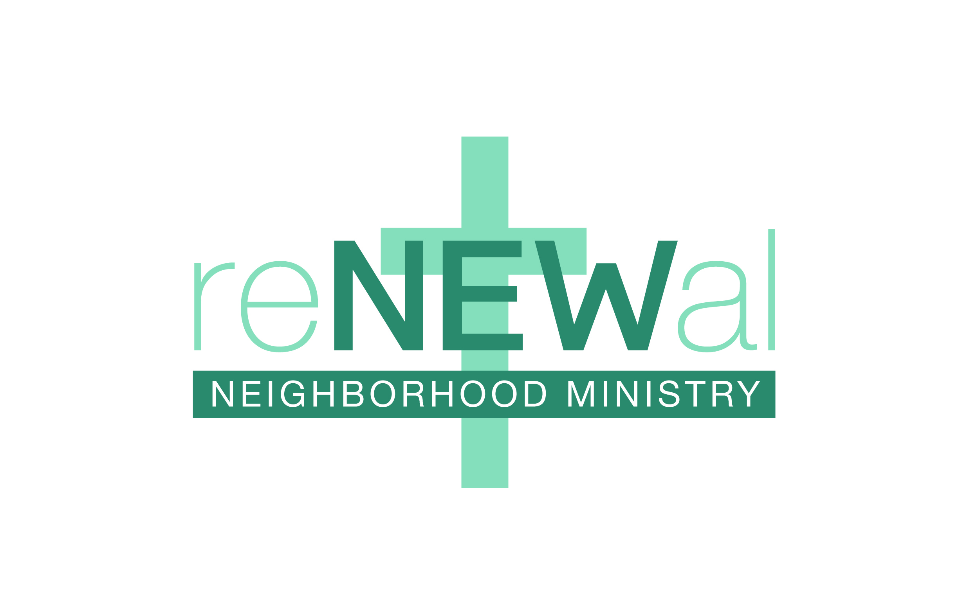
Thank you for registering your child to play in the Renewal Youth Sports Ministry soccer league. We are so glad you are joining us this year.

Our soccer program is divided into two divisions: the Junior Division, which includes kids who are currently in kindergarten through second grade, and the Senior Division, which includes kids currently in third through sixth grade.

We will be dividing our divisions into four teams. However, we are doing something a little different this year. ALL Junior Division players will practice together on Mondays, from 6:00 to 7:00. ALL Senior Division players will practice together on Tuesdays from 6:00 to 7:00. We believe practicing together will be more fun for the kids, will allow them to build more friendships, and will expose them to all of the coaches, while still allowing them to play games with the same group of kids each week.

Junior Division players will have games on Saturdays at either 10:00 or 11:00. Senior Division players will have games on Saturdays at either 12:00 or 1:00. Games begin Saturday September 11 and run through October 23. There will be no games on October 9 due to an event taking place at the church.

We ask for your cooperation in getting your player to practices and games regularly and on time. We understand that things sometimes come up that make it necessary for players to miss games or practices. However, regular attendance is expected. If your player cannot attend a game or practice, we ask that you let us know by sending an e-mail to this address or sending a text to 466-999-4208. Be sure to include your player's name with any e-mail or text! We have a full league this year, with players on a waiting list. If your player does not attend regularly, you may be asked to withdraw your player from the league so that other kids who want to play are able to participate.

This is an introductory level league, where players will be taught basic skills. We put a heavy emphasis on sportsmanship, from both players and fans. Please cooperate with the spirit of the league by cheering on all players and avoiding criticism of referees and other officials. If you have any questions or concerns, please contact either of us.

Each week we will be relying on Scripture to emphasize a character trait or life principle that kids can apply both on and off the field. This season we are emphasizing wisdom as taught through the book of Proverbs. We believe this is a key component that sets our program apart from others. We will discuss these principles at each practice and game. In addition, your player will have the opportunity to memorize a Bible Memory Verse each week. If they can accurately recite the weekly verse, they will receive a Bible Buck to use at our concession

stand. All players who accurately recite all nine Bible Memory Verses will receive a special prize at the end of the season. A list of all weekly Bible Memory Verses is included in our Devotional Handbook, which goes into more detail about why we make teaching and learning Scripture an important part of our ministry. The Bible Memory Verses give you an excellent
opportunity to help your child put the Word of God into their heart and to learn how to apply it in their daily lives.

Renewal Neighborhood Ministry is here to serve the families of our neighborhoods. If you ever have a need we can help you with or a prayer request you would like to share with us, please let us know. Also, we would love to have our families help out with coaching, the concession stand, the Bible Memory Verse table, and set up or clean up on game days. If you would like to volunteer, if there is anything we can help your family with, or if you have any questions or concerns, please let us know.

--
Clarence Abernathy
Vice President, Youth Sports Director

Mike Wilkins
President
Renewal Neighborhood Ministry

